

**STIWK 2124**

**WEB ENGINEERING**

**EXERCISE 1 : HTML DOCUMENT**

**SECOND SEMESTER SESSION 2024/2025 (A242)**

Name : DEVINDRAN A/L RAVICHANDRAN

Matric Number : 297506

Group : B

Lecturer : DR. RUZITA BINTI AHMAD

Date of Submission : 2 MAY 2025

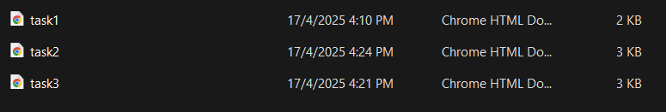

TASK 1:

|  |
| --- |
|  |

TASK 2:

|  |
| --- |
|  |

TASK 3:

|  |
| --- |
|  |